ITMS 528 Osint Project - AU8 Controls

To apply this control, I began by adding two new attributes to the sales_transactions data table.

The below SQL statement were executed to do just that



`order_time`, specifies the time an order was made on the server's local time.

`universal_time` simply converts the systems localtime to Coordinated Universal Time (UTC).

This resulted in the following changes to the sales_transactions data table:

**Before**

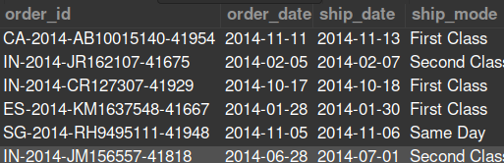

**After**

